Nepal College of Information Technology
Balkumari Lalitpur

Year: 2009 Sem: Spring
Program: B.E Time: 3hrs
FM: 100 PM: 50

Engineering Math-II

Attempt all questions.
1. Solve the differential equation
(a) xy' +y =y² logx (7)
(b) y" -y' =x³ (8)
2. (a) Solve the initial value problem
y" + 2y' +y =e^{-x} ,y(0)=-1 ,y'(0)=1 (8)

OR
Solve y" + 2y' +y =4e^{-x} logx
(b) Solve xy' -3y = k
by power series method (7)

3 (a) Find Laplace transform of (Any two) (4x2)
(i) t sin wt
(ii) e^{-3t} u(t)
(iii) 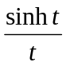
(b) Solve
y" + y =2 cos t , y(0) =3 , y'(0) =4
by using Laplace transform (7)

4 (a) Evaluate 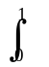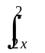e^{y2} dy dx (7)
(b) Find the volume bounded by the xy plane , the cylinder
x² + y² =1 and the plane x + y +z =3 (8)

5.(a) Evaluate 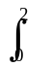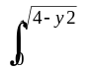cos(x² + y²) dx dy
by changing the Cartesian co-ordinate into an equivalent polar co-ordinate. (8)
(b) If u = log(x³+y³+z³-3xyz) show that
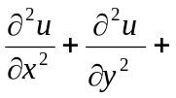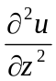= -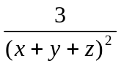 (7)

6. (a) State and prove Euler's theorem on homogenous functions and
if u = sin⁻¹[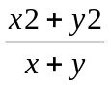], show that x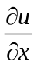+y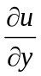=tanu (4+4)
(b) Find the maximum and minimum value of
f=2xy-5x²-2y²+4x-4 (7)

7 Solve the following (Any five) (2x5)
(a) Solve e^{x-y}dx + e^{y-x}dy =0
(b) Find integrating factor of 3y dx + 2x dy =0
(c) Find Laplace transform of 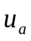(t)
(d) Laplace first shifting theorem
(e) Evaluate 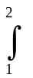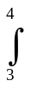dx dy
(f) If u=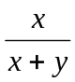 Find 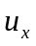and 